3 Nights, 4 Days
Muscat –-Nizwa-Wahiba Sands –Turtle Beach –Wadi shab
Day 01 -
Depart Muscat in the morning; our journey takes us along the Batinah to Nakhl “the date palm” grove where you can see the natural hot spring and the 350 year old Nakhl Fort.
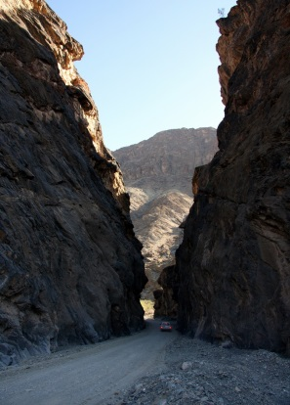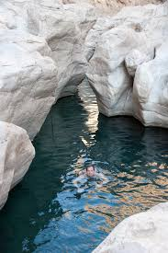We continue our journey along the loop to Wadi Bani Awf, climb through the Wadi will take us up the Jebel ‘mountain’ where at a point along the climb you can see the gorge below, which indeed looks like a snake and those that desire can make the trek into it, There are several small pools here suitable for bathing
We drive up the Mountain to one of the most charming picturesque mountain villages ever Billad Sayt where time seems to have stood still for ages, The village on top of the cliff is a spectacular sight when seen from the terraced farms below, which provide the basic needs for the local residents,
In the evening we will reach Nizwa, Where we spend our First Night of the tour
(Lunch & Dinner Optional)
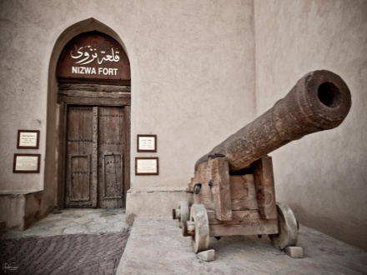
Day 02 –
Nizwa the capital of the interior is the birthplace of Islam in the Sultanate of Oman. Nizwa boasts of the famous Round Tower Fort, built in the 17th century,
We will visit the famous Nizwa Souq renowned for its Friday cattle auction, intricately hand-carved “Khanjars” (daggers) & ornamental silver jewellery.
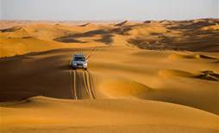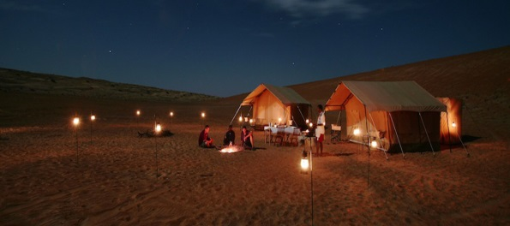Next to the Souq is Nizwa Fortress. The fort is a museum today and offers splendid views of this ancient town and the surrounding mountains.
Then to Jabrin, the finest of Oman’s castles built in the late 17th century, became a seat of Omani learning. The castle displays the highest achievement in Omani ceiling painting & beautifully executed woodcarvings.
The journey continues to Wahiba Sands, one of the most fascinating and mysterious regions of Oman. Notably, the dunes support an astonishing variety of flora and fauna and the ever changing patterns of dunes are a photographer's delight. Visitors can ride camels or experience the adventure of dune driving and visit local Bedouin family in their home to get a close up view of their lifestyle and share coffee & dates with the genuine Bedouins.
Evening enjoy the camp fire & Dinner. Overnight stay in Wahiba Sands.
(Lunch optional)
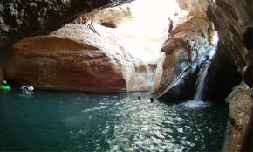
Day 03 –
After Breakfast we continue to Wadi Bani Khaled . It is one of the biggest and most beautiful Wadis in Oman. Enjoy a refreshing swim in its cool waters.
From here we drive to Sur, where we will have a small city tour before we drive to Ras al Hadd where you will spend a night
After dinner, we will drive you to Ras al Jinz Turtle’s sanctuary a protected Green turtle nesting reserve. Where you can see Oman`s great sea turtles on the beach nest and lay eggs, you have Possibilities to see baby turtles hatching from some nests.
Overnight stay in Ras Al Hadd. 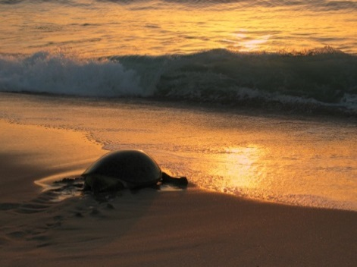
(Lunch & Dinner optional)
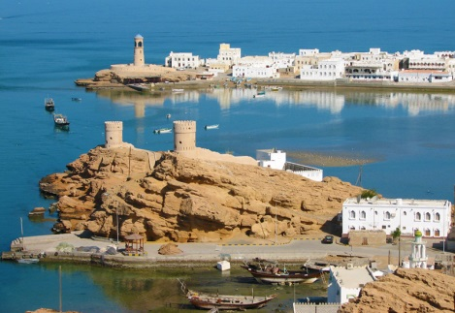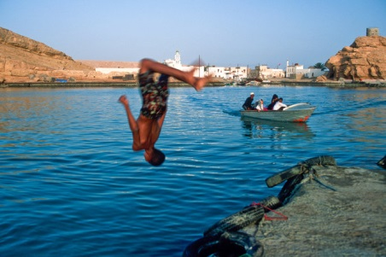
Day 04 –
After Breakfast depart to Sur. Then from there we drive along the coastal road. The journey continues to Wadi Tiwi and the graded track to Wadi Shab, one of Oman's most spectacular wadis, flowing with fresh water most of the year alongside banana plantations and rocky paths. and proceed to Fins where a beautiful white sandy beach beckons for a relaxing swim. The drive continues to a Photo stop of Bamah Sinkhole then to Quriyat, a small coastal fishing village and proceeds to Muscat.
Late Afternoon return Back to Muscat.
(Lunch Optional)

PRICE : From 1,105 USD per person ( min. 2 persons)

INCLUDES:
:3 Nights Accommodation in a Double/twin room sharing basis with breakfasts
:4WD Vehicle with English speaking Guide/Driver
:Dinner in the Desert
:Water/soft drinks enroute
:All entrance fees/permits.

